***Experiment No: 09***

***Experiment Name:***

Implementation of Optimal Page Replacement Algorithm

***Objectives:***

In this lab we will learn about the Optimal page replacement algorithm, Implementation of Optimal page replacement algorithm by using c program and testing the program with different inputs and find outputs.

***Optimal page replacement algorithm:***

This algorithm replaces the page that will not be used for the longest period of time. The moment the page fault occurs, some set of pages are in memory. One of these page will be referenced on the very next instruction. Other pages may not be referenced until 10,100 or perhaps 1000 instructions

***Source Code:***

#include<stdio.h>

void main()

{

int nop,nof,page[20],i,count=0;

printf("\nEnter the No. of Pages: ");

scanf("%d",&nop);

//Store the no of pages

printf("\n Enter the Reference String: \n");

for(i=0; i<nop; i++)

{

scanf("%d",&page[i]); //Array for Storing Reference String

}

printf("\n Enter the No. of frames: ");

scanf("%d",&nof);

int frame[nof],fcount[nof];

for(i=0; i<nof; i++)

{

frame[i]=-1; //Frame Array

fcount[i]=0; // Track the next Availability of frames

}

i=0;

while(i<nop)

{

int j=0,flag=0;

while(j<nof)

{

if(page[i]==frame[j]) // Checking Whether the Page is Already in frame or not

{

flag=1;

}

j++;

}

j=0;

printf("\n");

printf("\t%d",page[i]);

if(flag==0)

{

if(i>=nof)

{

int max=0,k=0;

while(k<nof)

{

int dist=0,j1=i+1;

while(j1<nop)

{

if(frame[k]!=page[j1]) //Calculating Distances of pages that are in the frame to their next occurence

dist++;

else

{

break;

}

j1++;

}

fcount[k]=dist; //Storing Distances into array

k++;

}

k=0;

while(k<nof-1)

{

if(fcount[max]<fcount[k+1]) //Finding out the maxximum distance

max=k+1;

k++;

}

frame[max]=page[i];

}

else

{

frame[i%nof]=page[i];

}

count++; // Increasing Page Fault.

while(j<nof)

{

printf("\t%d",frame[j]);

j++;

}

}

i++;

}

printf("\n\nPage fault is: %d\n",count);

}

***Output:***

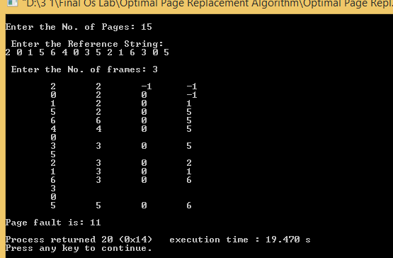

***Discussion:***

After doing this lab we have learnt about the Optimal page replacement algorithm. We also have learnt how to implement Optimal page replacement by using C programming language.